**Leading Care Services**

**Franchise Opportunity**

**Who We Are**

For nearly a decade Leading Care Services has provided care based on a framework of empowerment, wellbeing, and healthy ageing. We ensure individuals have choice and control to maintain their independence and confidence while getting the support they need in the place they call home.

**What We Do**

Our superior services are here to support the health and social wellbeing of all that we serve. Such services include Non-medical Personal Care, Skilled Nursing, Non-Emergency Medical Transportation, Residential Care Homes, Community Engagement Opportunities, and On-going Training.



Founder Bio

A caregiver both by nature and profession Estella Griffen founded Leading Care Services in 2015 to address the critical need for quality and compassionate home care. Leading Care Services offers support to assist older adults and individuals with disabilities age in place safe and comfortably.

While caring for hundreds of patients throughout the years Estella saw firsthand how the families of these individuals would take on a considerable amount of stress to ensure their loved ones received the care they deserved, oftentimes at the expense of their own work, health, and family obligations. The team at LCS thrives to put families at ease when services are being provided.

Estella believes that these individuals benefit greatly from being social and engaging in their communities. By volunteering and attending social events they regain their sense of purpose and experience more fulfilled lives.

Being that caregivers are the lifeblood of business, Estella makes it her mission to offer fair living wages to support them and their families. She puts emphasis on cross training, learning new ways of preventing caregiver “burnout” and offers various incentives to ensure that caregivers feel cared for.

The need is great, but the vision is greater. **Together we Lead.**

Services

**Non-medical Personal Care**

Includes support with activities of daily living such as bathing, grooming, incontinence care, light house-keeping seasonal chores, meal prep, cooking, and companion care.

**Skilled Nursing**

Studies have shown that patients get better faster at home with the support of Nurses, home health aides, physical, occupational, and speech therapist this is absolutely possible.

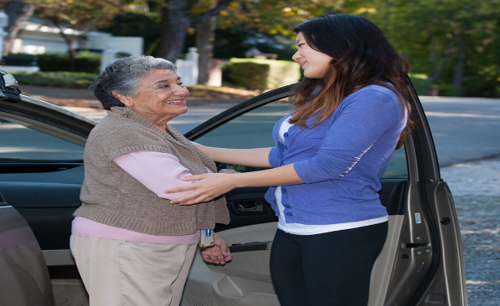**Non-Emergency Medical Transportation**

Every year thousands of preventative and critical medical appointments are missed or canceled due to lack of transportation. This puts a significant burden on the healthcare system. Non-emergency medical

transportation offers door to door drop off and handicap accessible vehicles to get patients where they need to be.

**Residential Care Home**

When home is not an option a nursing home doesn’t have to be. A Residential Care Home offers the amenities of an assisted living facility but in a small home-like setting. Residents are offered shared or private rooms, three meals a day, housekeeping, and engaging activities with new friends.

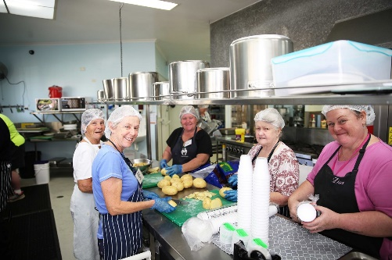 **Community Engagement**

The benefits of volunteering are endless for aging adults. It fosters relationships, creates a sense of purpose and it gives them an opportunity to give back to the communities they love. From planting fruit trees to leading a virtual book club there is something for everyone.

Leading Care Services

9595 Whitley Drive Suite 201 Indianapolis Indiana 46240

Tel. 317-579-5523

www.LeadingCareServices.com

**The Numbers**

The market for home care is sizable, with the state being home to nearly 2.4 million people that are at or near retirement age. Studies have shown that the vast majority of these individuals plan to age in place as opposed to being institutionalized. The same is true for individuals that would like to recover in their homes from surgical procedures where home care can be equal or even better than that received in a hospital setting or rehabilitation facility. Research shows that individuals recover faster, with fewer complications, at home than in a hospital.

By 2030, one out of every five people living in Indiana alone will be 65 or older, according to population projections released by Indiana Business Research Center. More than 966,000 senior citizens called Indiana home in 2015. That number is expected to grow 46% by 2030 to exceed 1.4 million. By 2050, the number of people ages 65 and older will be 1.5 million - a growth of 57% from 2015 levels.

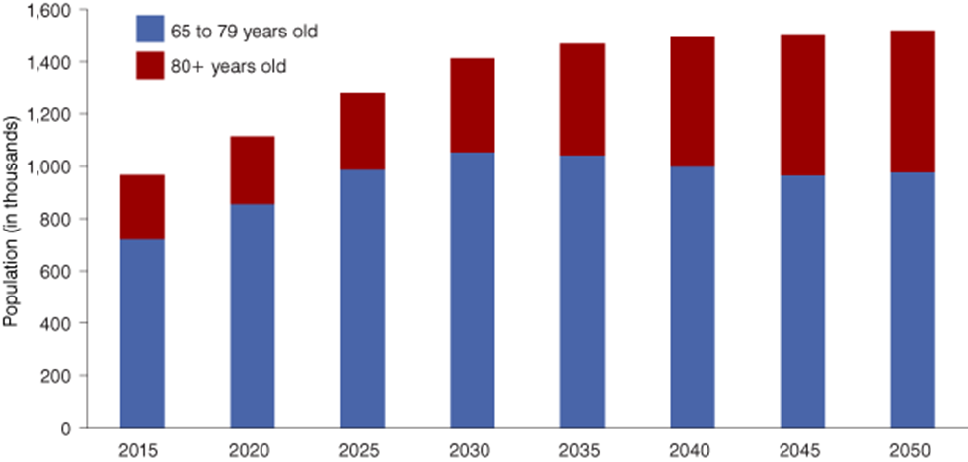

**Source: Indiana Business Research Center**



**Source: Indiana Business Research Center.**

According to Base Stats Industry Markets Report, sales for home care totaled $39,912,618. The growth of the healthcare industry and the aging population will both contribute to the growth of demand for caregivers. The need for Personal Care Attendants and Homemakers will grow faster than the average for all occupations. The demand grew by 28% from 2006 to 2016 and is projected to grow 33% from 2020 to 2030 according to U S Bureau of Labor statistics the growing demand for in home treatment will also contribute to the growing demand for caregivers. Excellent job opportunities will be available with about 599,800 openings for caregivers are projected to grow each year over the next decade.



**“The number of older adults in the US is projected to increase by 18 million between 2020 and 2030, meaning that 1 in 5 Americans will be 65 years old and over by 2030 and 95 million by 2060.”**

-Census.gov

**Opportunity Awaits**

As the population of seniors continues to grow,

so does the need for senior care services

**By 2030, one out of every five people living in Indiana alone will be 65 or older, according to population projections released by Indiana Business Research Center. More than 966,000 senior citizens called Indiana home in 2015. That number is expected to grow 46% by 2030 to exceed 1.4 million. By 2050, the number of people ages 65 and older will be 1.5 million - a growth of 57% from 2015 levels.**

This is your opportunity to help lead the way to a better home care experience by increasing resources and services to support this growing population**.**

**Minimum Franchise Fee of $35,000 includes:**

**- Brand Recognition**

**- Ongoing support and tr**aining

**Leading Care Services**

[**www.LeadingCareServices.com**](http://www.LeadingCareServices.com)

[**AngelsCareForMe@gmail.com**](mailto:AngelsCareForMe@gmail.com)

**317.579.5523**

**- Low cost and low risk**

**- Recession resilient Industry**

**- Established Network**